**Cell Description:**This is a standard FILLler (FILLL) cell. The purpose of this cell is to allow the place and router to fill spaces between cells with a blank cell. This is used to ensure that the nwell regions implanted in the substrate are continuous for each row of cells.

**Cell Size:**

|  |  |  |
| --- | --- | --- |
| **Drive Strength** | **Height (μM)** | **Width (μM)** |
| FILL1 | 27.0 | 2.4 |
| FILL2 | 27.0 | 4.8 |
| FILL3 | 27.0 | 7.2 |
| FILL4 | 27.0 | 9.6 |
| FILL8 | 27.0 | 19.2 |

**CMOS Layout:**

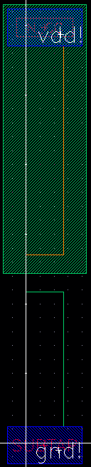

Figure : CMOS layout view for the FILL1 cell.

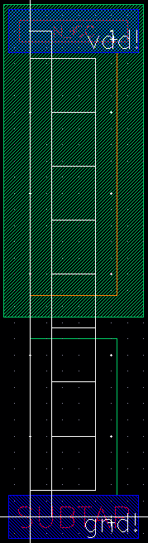

Figure : CMOS layout view for the FILL2 cell.

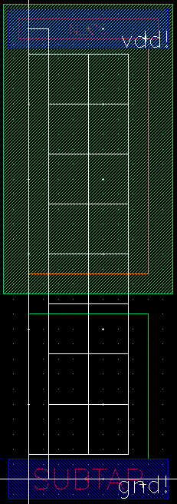

Figure : CMOS layout view for the FILL3 cell.

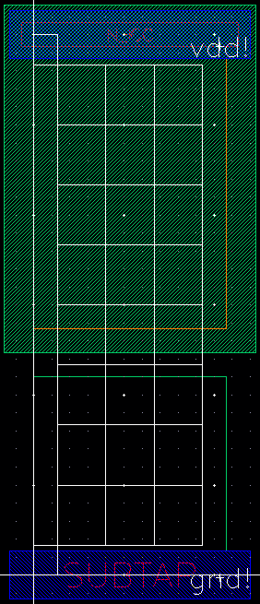

Figure : CMOS layout view for the FILL4 cell.

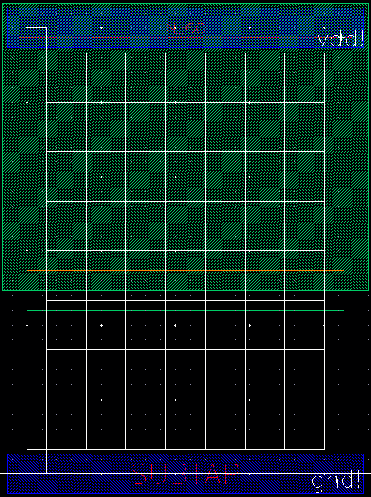

Figure : CMOS layout view for the FILL8 cell.